**System Request – Adelante Hispanic Achievers**

**Project Sponsor:** Mara Maldonado, Director and Dustin Bishop, Volunteers/Program Operations and Development

**Business Need:**

Adelante Hispanic Achievers has a need for many IT improvements that will help make their operations more efficient:

* Implement reliable data backup
* Maximize efficiency in grant applications and tracking
* Improve data collection, usability, and storage
* Increase accessibility to necessary documents
* Improve user friendliness among systems
* Increase efficiency in scheduling and time management for volunteers
* Streamline communication with students, parents, volunteers, and donors
* Improve community relations
* Eliminate paper-based sign in

**Business Requirements:**

There are a combination of various products and services to address the business needs listed above:

* Maintain secure and reliable backup:
* Consolidate and centralize records
* Provide functions to search, sort, and manipulate data
* Generate statistical reports
* Track active grant deadlines and all AHA relevant events
* Attendance records for determining active/inactive student status
* Manage contact data for parents, students, volunteers, and donors
* Enhance online donation function
* Maintain and update scheduling
* Display vacant positions in the volunteer program
* Create and implement digital sign-in system

**Business Value:**

AHA can be benefitted in the following ways:

* $40,000 increase in revenue in the first year

This is from the possibility of acquiring four new grants with the time that will be saved in processing and drafting grant applications. It is estimated that current grant writing time will decrease from 20 hours per grant to 14.5 hours. The reporting time for approved grants is currently estimated at 7.5 hours, but the new system will cut that to 3 hours per funded grant. The time savings from the new system allows the total grants written to increase from 15 per year to 22. With a 60% approval rate, this increases the total funded grants from 9 to 13. With a $10,000 average grant amount, this equates to a $40,000 increase in grant revenue. In addition, grant writers will have an additional 9.5 hours free per year from the system reducing the time spent applying to grants and reporting of grants. The staff could use that time to apply to additional grants, plan fundraisers or initiate donation drives.

* 5.5% increase in volunteer to student time

This is from the possibility that the given hour and a half with a 10-15 minute volunteer and student sign in time will be cut from 10-15 to about 5 minutes or less.

* 5-25% increase in individual donations
  + low: 5% increase -- (106 * 5%) * 75 = $375
  + mid: 15% increase-- (106 * 15%) * 75 = $1125
  + high: 25% increase -- (106 * 25%) * 75 = $1950

This is an estimate attributable to the donor database tracking, engagement through contact management, and focused donation drives. It was stated that Adelante received $8000 in donations last year. It was also estimated that they received an average of $75 ($50-$100) per donation. That means they received roughly 106 individual donations (8000/75). Therefore, an 15% increase in individual donations could result in $1125 added donation revenue ((106 *15%) * 75).

* 5-25% increase in event revenue
  + low: 5% increase -- $6875 * 5% = $344
  + mid: 15% increase -- $6875 * 15% = $1,031
  + high: 25% increase -- $6875 * 25% = $1,719

On average, AHA has made $6,875 in fundraising events between the years of 2010 - 2013. These numbers were provided by AHA. Due to email blasts that are targeted to a broad range of donors, this would provide for more efficient communication skills and could increase their revenue.

Please see the NPV Analysis in 7.1 Appendix A for further explanation.

**Special Issues or Constraints:**

* Grants must be fully spent by deadlines
* Parents must be included in registration
* Systems must be compatible with current equipment
* Limited budget
* Must comply with FERPA
* HIPAA compliant if special needs are present

**Narrative**

**Problem Statement:**

For the last decade, Adelante Hispanic Achievers has provided an important and invaluable service to the Hispanic youth community in Louisville. There are many students who have benefited from taking advantage of the after-school programs sponsored by Adelante.

Adelante provides great support to the Louisville Metro Hispanic community, however, there are a number of issues that handicap AHA’s ability to make the best use of their time and energy. Currently, they are at maximum capacity, and now more than ever need to take full advantage of available information technology systems to streamline their business processes. AHA faces a major number of challenges in their technological systems including:

* Inefficient data collection, management, and backup
* Lack of centralized and secure database
* No statistical reporting capabilities
* No grant and donor tracking
* No attendance management
* No communication capability
* Poor website user interface
* Website is not easy to maintain and update
* Inefficient scheduling system
* Inefficient paper based documentation

**Vision of expected solution:**

In order to address AHA’s problems effectively, they will need a centralized database that serves a cross-functional purpose to connect various aspects of the organization. It is vital to the organization to track grant application progress, funds allocation, donor information, and volunteer participation. Another important aspect that needs to be included in the website design is the ability to have a message board to make communication more effective. Additionally, the website needs to be updated and tailored to their usage demands, enabling easy access for users and editing capabilities for admin. Finally, all of their information needs to be securely stored and backed up to avoid catastrophic data loss or abuse.

**Business Case:**

Value of proposed solution:

* $40,000 increase in revenue

This is from the possibility of acquiring four new grants with the time that will be saved in processing and drafting grant applications. It is estimated that current grant writing time will decrease from 20 hours per grant to 14.5 hours. The reporting time for approved grants is currently estimated at 7.5 hours, but the new system will cut that to 3 hours per funded grant. The time savings from the new system allows the total grants written to increase from 15 per year to 22. With a 60% approval rate, this increases the total funded grants from 9 to 13. With a $10,000 average grant amount, this equates to a $40,000 increase in grant revenue. In addition, grant writers will have an additional 9.5 hours free per year from the system reducing the time spent applying to grants and reporting of grants. The staff could use that time to apply to additional grants, plan fundraisers or initiate donation drives.

* 5.5% increase in volunteer to student time

This is from the possibility that the given hour and a half with a 10-15 minute volunteer and student sign in time will be cut from 10-15 to about 5 minutes or less.

* 5-25% increase in individual donations
  + low: 5% increase -- (106 * 5%) * 75 = $375
  + mid: 15% increase-- (106 * 15%) * 75 = $1125
  + high: 25% increase -- (106 * 25%) * 75 = $1950

This is an estimate attributable to the donor database tracking, engagement through contact management, and focused donation drives. It was stated that Adelante received $8000 in donations last year. It was also estimated that they received an average of $75 ($50-$100) per donation. That means they received roughly 106 individual donations (8000/75). Therefore, an 15% increase in individual donations could result in $1125 added donation revenue ((106 *15%) * 75).

* 5-25% increase in event revenue
  + low: 5% increase -- $6875 * 5% = $344
  + mid: 15% increase -- $6875 * 15% = $1,031
  + high: 25% increase -- $6875 * 25% = $1,719

On average, AHA has made $6,875 in fundraising events between the years of 2010 - 2013. These numbers were provided by AHA. Due to email blasts that are targeted to a broad range of donors, this would provide for more efficient communication skills and could increase their revenue.

Please see the NPV Analysis in 7.1 Appendix A for further explanation.

**Organizational Feasibility:**

The organization has made several requests regarding their website and database specifically to enhance the centralization of data and accessibility for users. The facets of our design will be congruent with the organization's goals.

**Technical Feasibility:**

We are confident in the ability to build the system for Adelante Hispanic Achievers. The largest features that will be designed for AHA are the website and the centralized database. Given the administration's experience with Excel, we believe they have adequate experience to utilize the database with initial training. They currently have a website that they are able to manage and update so upgrading the features available to them would also require some initial training, however we believe that they would quickly adjust to the new features.

**Economic Feasibility:**

AHA can be benefitted in the following ways:

* $40,000 increase in revenue

This is from the possibility of acquiring four new grants with the time that will be saved in processing and drafting grant applications. It is estimated that current grant writing time will decrease from 20 hours per grant to 14.5 hours. The reporting time for approved grants is currently estimated at 7.5 hours, but the new system will cut that to 3 hours per funded grant. The time savings from the new system allows the total grants written to increase from 15 per year to 22. With a 60% approval rate, this increases the total funded grants from 9 to 13. With a $10,000 average grant amount, this equates to a $40,000 increase in grant revenue. In addition, grant writers will have an additional 9.5 hours free per year from the system reducing the time spent applying to grants and reporting of grants. The staff could use that time to apply to additional grants, plan fundraisers or initiate donation drives.

* 5.5% increase in volunteer to student time

This is from the possibility that the given hour and a half with a 10-15 minute volunteer and student sign in time will be cut from 10-15 to about 5 minutes or less.

* 5-25% increase in individual donations
  + low: 5% increase -- (106 * 5%) * 75 = $375
  + mid: 15% increase-- (106 * 15%) * 75 = $1125
  + high: 25% increase -- (106 * 25%) * 75 = $1950

This is an estimate attributable to the donor database tracking, engagement through contact management, and focused donation drives. It was stated that Adelante received $8000 in donations last year. It was also estimated that they received an average of $75 ($50-$100) per donation. That means they received roughly 106 individual donations (8000/75). Therefore, an 15% increase in individual donations could result in $1125 added donation revenue ((106 *15%) * 75).

* 5-25% increase in event revenue
  + low: 5% increase -- $6875 * 5% = $344
  + mid: 15% increase -- $6875 * 15% = $1,031
  + high: 25% increase -- $6875 * 25% = $1,719

On average, AHA has made $6,875 in fundraising events between the years of 2010 - 2013. These numbers were provided by AHA. Due to email blasts that are targeted to a broad range of donors, this would provide for more efficient communication skills and could increase their revenue.

Please see the NPV Analysis in 7.1 Appendix A for further explanation.

Cost to AHA:

* Content Management System: Free if open source software is used.
* Database Management System: Azure is offered through Microsoft with a cost of $4.99/month minimum.
* Web hosting: GoDaddy provides backup, free domain, unlimited storage, and thousands of email addresses for $7.99/month. (AHA already has a 3-year subscription)
* Alternative web hosting: Winhost provides web and database hosting for $7.95/month.
* The total cost is $12.98 per month and $12.94 with alternative web hosting. The cost is very minimal, but necessary to incur in order to accomplish AHA’s goals.

1-year basis analysis

(40,000+1125+1031) - (12.98 * 12) = $42,000.24

**Process Modeling**

Process models are simply a visual representation of the basic business activities performed by an organization. The diagrams help identify and organize the various processes to help users and analysts develop a better understanding of the activities themselves and the timing of these functions. The As-Is Model shows the business processes as they are being performed before the implementation of a new system. The To-Be Model represents the functions as they will progress after implementation.

As-Is Model:

Current System

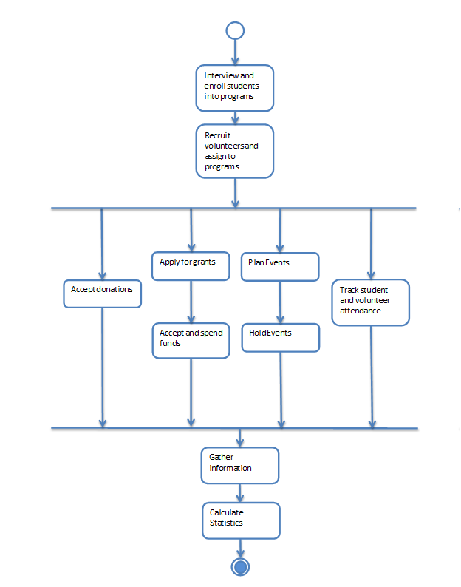

To-Be Model:

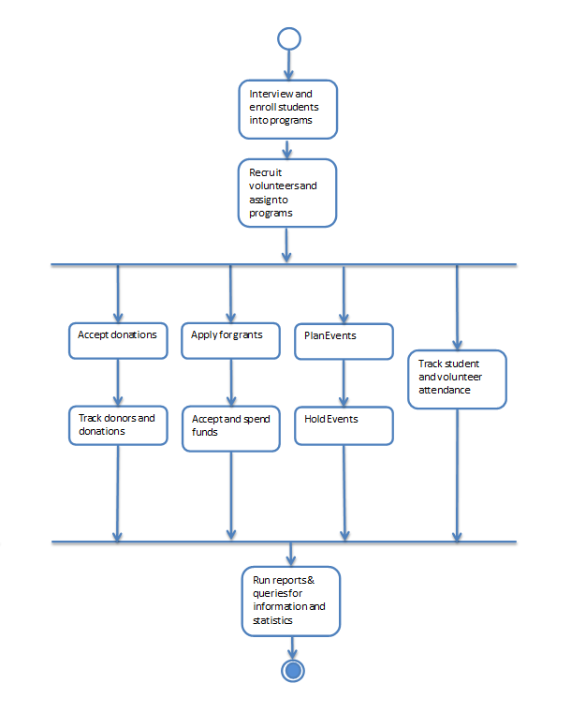

Revised Business Processes

**Agile User Stories**

These high-level stories are intended to define a requirement with just enough information for the team to have a basic idea of the amount of effort that is required to implement it, and its value to the organization. The four examples below are good representations of Adelante’s user stories.

|  |  |  |  |
| --- | --- | --- | --- |
| **Title** | Database Construction | | |
| **As...** | Altera Design | | |
| **I want to...** | create a DBMS to track various aspects of AHA | | |
| **So that...** | AHA can monitor and track progress, statistics, and growth | | |
|  | 4 | Quinn Banet | 4 |
| ID: 1 | **Value** (1-4, 4 high) | **Author** | **Estimate** (1-4, 4 high) |

|  |  |  |  |
| --- | --- | --- | --- |
| **Title** | Messaging Boards | | |
| **As...** | Altera Design | | |
| **I want to...** | create web based messaging boards | | |
| **So that...** | AHA can communicate more effectively and have more accessible communication for all staff, volunteers, parents, and students | | |
|  | 1 | Quinn Banet | 2 |
| ID: 2 | **Value** (1-4, 4 high) | **Author** | **Estimate** (1-4, 4 high) |

|  |  |  |  |
| --- | --- | --- | --- |
| **Title** | Website Ease of Access / Updates | | |
| **As...** | Altera Design | | |
| **I want to...** | set up a website that is easy to update, maintain, and access | | |
| **So that...** | the website is easily manageable for users and admins and aesthetically pleasing to any and all visitors | | |
|  | 3 | Quinn Banet | 3 |
| ID: 3 | **Value** (1-4, 4 high) | **Author** | **Estimate** (1-4, 4 high) |

|  |  |  |  |
| --- | --- | --- | --- |
| **Title** | Secure and Back-up Information | | |
| **As...** | Altera Design | | |
| **I want to...** | securely backup and store AHA’s information | | |
| **So that...** | AHA avoids mass data loss and retains old information | | |
|  | 2 | Quinn Banet | 1 |
| ID: 4 | **Value** (1-4, 4 high) | **Author** | **Estimate** (1-4, 4 high) |

**Team Charter**

**Team Goals:**

As a team, we would like to actively and effectively tackle each assignment. We aim to be very thorough and detailed to get what AHA is looking for, but at the same time be very efficient in how we work. Here are some realistic goals that we would like to set as a team:

* Have assignments ready before the due date so we can review them before submission. In doing this we aim to have ample time to prepare for each iteration presentation.
* Give everyone equally distributed responsibilities and opinions. At the beginning of each iteration we go over individual roles in addition to team roles. The purpose of this is to make sure everyone's clear on what is expected at each assignment and to ensure that our work is fluid.
* Work together in a manner that accomplishes our end result, rather than causes quarrels among the team. This is especially important with a semester long project as we will be working together for 15 weeks.
* Treat all disagreements cautiously. In the event of a disagreement we have decided that voting should handle how to move forward. In doing this we hope to minimize the effect of disagreements and continue our work in a productive and professional manner.

**Team Meetings:**

Team meetings will be held on a weekly basis with all team members present. We will agree on a common meeting spot and meet however long the group can so that we can delegate assignments, split tasks, and even share thoughts by working together to get everyone’s opinion on the matter. The work will be further divided among team members to individually work on assignments.

**Team Communication:**

Communication will be held primarily through group text with all document sharing done over google drive. This is the most reliable and effective way of communication in order to ensure rapid response time.

**Team Decisions:**

As a team, we feel it is best to stick to simplicity when it comes to disagreements. We will make decisions based on majority and result to team votes if necessary. We feel this is the best and most consistent way to deal with building consensus, making decisions, and resolving conflicts. We also feel that at times to uphold a fair working relationship with other group members, compromise is a necessity and vital to accomplishing our goals.

**Project Repository:** Our team will maintain project documentation mainly through google drive to keep all documents in a centralized location. Email will be used when necessary to send files or additional documents not compatible or necessary to be included in google drive. It is important to have all documents located in one place to ensure all team members can see the most updated versions. This way, everyone is informed and can edit the documents as deemed necessary.